AI Weather wise API
BRAINSTORMING & IDEATION PHASE

Date | 28-09-2026
Team ID | SWTID-2026-5068
Project Name | AI WeatherWise API
Maximum Marks | 4 Marks

AI Weather wise API
1. Brainstorming & Ideation Phase
The ideation phase was carried out by observing the difficulties users may experience while checking and interpreting weather information. Although many weather applications offer detailed data, users may not always understand the information quickly or know how it can be used for everyday planning.
Based on these observations, the idea for AI Weather wise API was formed as a simple, user-friendly, and informative weather application. The primary purpose is to present reliable weather details in a clear format and assist users in planning their daily activities according to weather conditions.
Key Ideas Identified
• Show the present weather condition in a clear manner.
• Display temperature, humidity, wind speed, and precipitation details.
• Offer forecasts for the coming days.
• Use a clean, simple, and visually appealing interface.
• Enable users to understand weather conditions without difficulty.
• Keep the application easy to access and convenient to use.
2. Problem Identification
Weather information is useful for travelling, outdoor activities, farming, education, and everyday scheduling. However, users can find it difficult to identify the most important information when an application has a complicated design or displays too much data at once.
AI Weather wise API addresses this issue by arranging essential weather information in a simple, organized, and user-friendly format.
3. Proposed Solution
AI Weather wise API is proposed as an intelligent weather information application that gathers and presents weather details in an easy-to-read format. Users can view current conditions as well as upcoming forecasts, allowing them to make suitable plans based on the expected weather.
The proposed system gives importance to simplicity, clarity, usability, and quick access to useful weather information.
4. Objectives
The major objectives of the AI Weather wise API project are:
1. To present weather information in a clear and easy-to-understand format.
2. To show current weather conditions along with future forecasts.
3. To display important parameters such as temperature, humidity, wind speed, and rainfall.
4. To develop a responsive and user-friendly interface.
5. To support users in planning their everyday activities according to weather conditions.
5. Key Features
• Current weather details
• Temperature display
• Humidity details
• Wind speed and direction
• Rainfall and precipitation information
• Short-term and upcoming forecasts
• Location-based weather details
• Simple and responsive user interface
• Easy visual presentation of weather conditions
6. Expected Outcome
The expected result of the AI Weather wise API project is a convenient weather application through which users can quickly access essential weather information. The system is intended to reduce unnecessary complexity and show relevant details in a clear and understandable manner.
It is expected to help users understand weather conditions easily and use the information for better daily planning.
7. Future Enhancement
In future versions, AI Weather wise API can be improved by adding severe-weather alerts, personalized notifications, interactive weather maps, historical weather reports, support for multiple locations, and more advanced forecasting capabilities.
8. Conclusion
AI Weather wise API is developed with the aim of making weather information simple, accessible, and useful for everyday users. By presenting weather data in an organized and understandable way, the application can help users quickly identify current conditions and prepare for upcoming weather.
The project shows how technology can be applied to deliver useful environmental information and support everyday decision-making. With additional improvements and features, AI Weather wise API can be developed into a more advanced and comprehensive weather information platform.
SCREEN SHOT: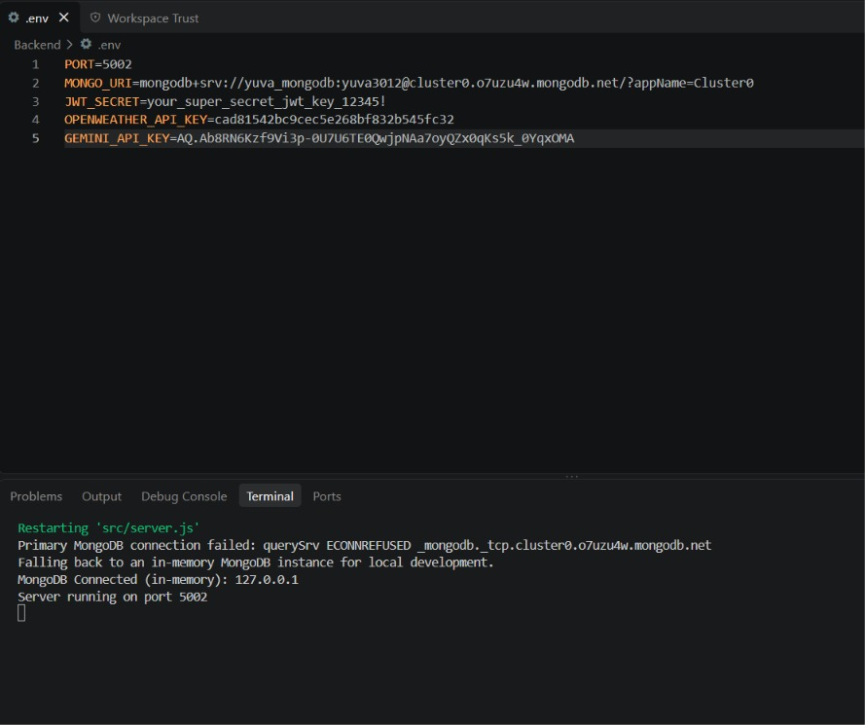
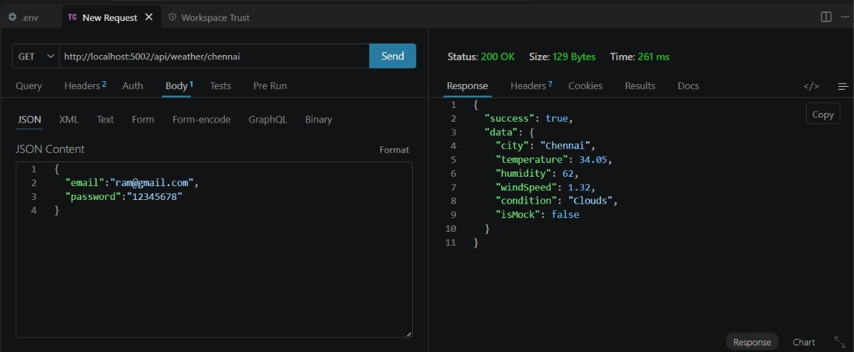

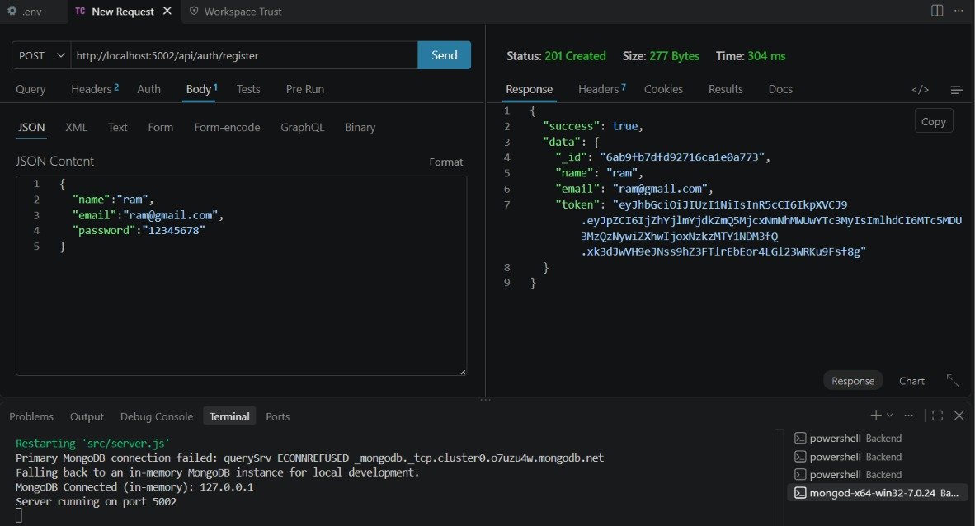
API TESTING VIDEO LINK: api testing.mp4
DEMO VIDEO LINK: backend demo.mp4
CODE DRIVE: code

